Contents

1. SPRING TOOL SUITE INSTALLATION STEPS 2

1. Download link 2

2. Extract *.jar file 2

# SPRING TOOL SUITE INSTALLATION STEPS

## Download link

<https://spring.io/tools>

## Extract *.jar file

Click on the self-extracting *.jar file and the new folder will be created => “sts-4.9.0.RELEASE”.

Move that folder wherever you think appropriate, maybe putting it in “Program Files” folder has the most sense.

Create desktop shortcut.

Installation is then complete.

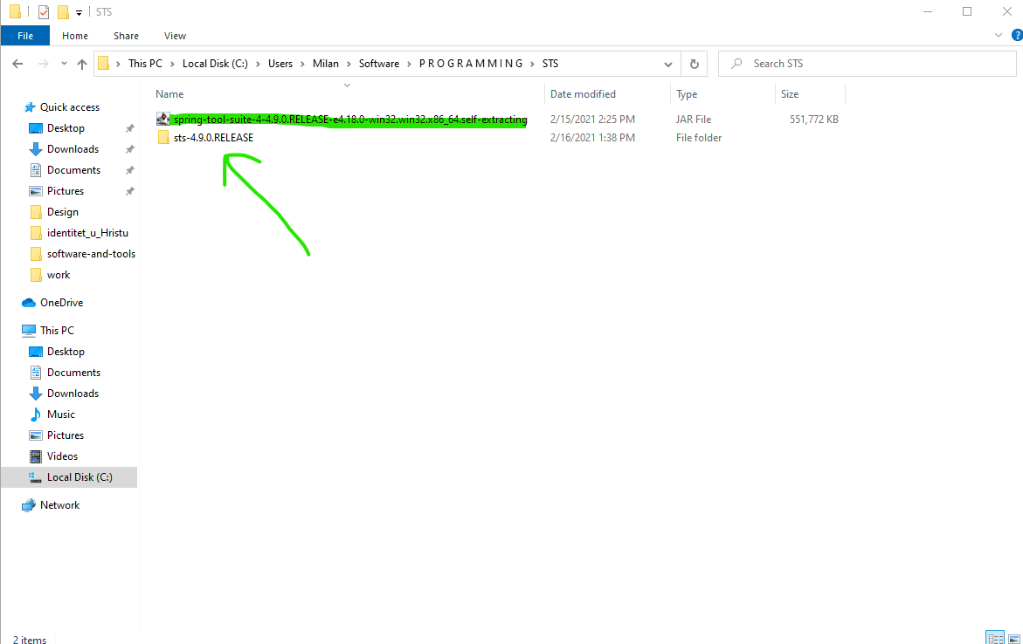

Figure 1 - Extracting *.jar file